**THEME: PROMOTING EQUITABLE YOUTH OUTCOMES IN THE AFRICA CONTINENTAL FREE TRADE AREA (AFCFTA) THROUGH SUSTAINABLE DOMESTIC REVENUE MOBILISATION AND ALLOCATION.**

**YOUTH & GOVERNMENT CONSULTATIVE MEETING TO INFORM THE AFCFTA PROTOCOL ON WOMEN & YOUTH IN TRADE AND PROTOCOL ON DIGITAL TRADE / E-COMMERCE.**

**COMPREHENSIVE REPORT**

**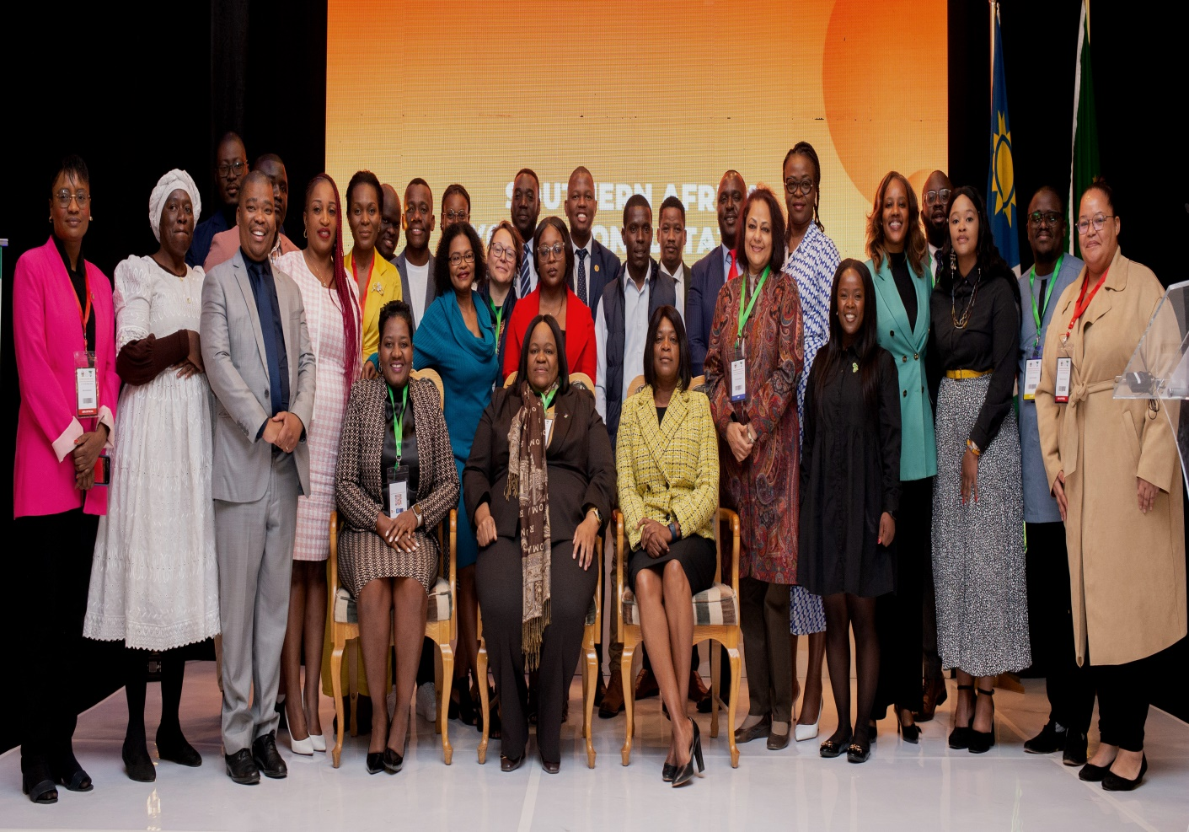*A cross-section of the dignitaries who attended the meeting pose for a group photo*.**

**Venue:** Windhoek, Namibia

**Date:** 22nd- 23rd June 2023.

Contents

BACKGROUND 3

CONTEXT 3

OBJECTIVES OF THE CONSULTATIONS 5

Overall Objective: 5

Specific Objective 5

EXPECTED OUTPUTS 5

PARTICIPANTS 6

STRUCTURE OF THE CONSULTATIONS 6

PRAYER 6

OPENING STATEMENT 7

KEYNOTE ADDRESS 10

PARTNER REMARKS 15

# BACKGROUND

The signature of the Agreement establishing the African Continental Free Trade Area (AfCFTA) on 21st March 2018 marked a historic milestone for economic integration in Africa, creating a market of 1.3 billion people with a combined gross domestic product (GDP) valued at US$3.4 trillion. The Agreement envisages boosting intra-African trade through the gradual elimination of tariffs and the removal of nontariff barriers to intraregional trade – on goods and services. The start of trade under the AfCFTA Agreement began on 01 January 2021. As of 31 July 2022, 54 of the 55 African Union (AU) Member States had signed the AfCFTA Agreement, and 43 countries deposited their instruments of ratification. A single market created under the AfCFTA Agreement presents considerable opportunities for accelerating intra-African trade and using trade more effectively as an engine for inclusive growth and sustainable development.

# CONTEXT

Africa has the world's youngest population, with over 400 million young people aged 15 to 35 years. To spur Africa's economic progress and advance SDGs, the critical mass of youth and women remains the main anchor of the AfCFTA, which is the "Agenda 2063," the continent's development blueprint. This massive single continental market is expected to increase intra-African trade by 52.3 per cent, deepen continental integration, increase productivity, create more jobs, and avail substantial gender-balanced opportunities by including women and youth in Africa's trade liberalization. The World Bank estimates that the AfCFTA will increase Africa's income by $450 billion by 2035 and increase intra-African exports by more than 81 per cent. The AfCFTA will address the excessively high trade costs and steep tariff barriers in many countries that limit the potential of women and youth in the business sector, ultimately stifling economic growth and undermining the continent's overall development.

Beyond trade, the African Continental Free Trade Area (AfCFTA) Agreement explicitly seeks the development of Africa’s people. The preamble of the Agreement underscores the importance of gender equality for the development of international trade and economic cooperation in the region. Under article 3(e), one of the general objectives aims to “promote and attain sustainable and inclusive socio-economic development, gender equality and structural transformation”. Article 27.2(d) of the Protocol on Trade in Services also makes explicit reference to improving the export capacity of formal and informal service suppliers, with particular attention to micro-, small- and medium-sized operators and “women and youth service suppliers”. These provisions clearly demonstrate the commitment of African countries to gender equality, women empowerment and youth development. As a result, the AfCFTA is expected to create new trading and entrepreneurial opportunities for women in the formal and informal economy across various sectors, including agriculture, manufacturing and services sectors.

The benefits under the Agreement for women and youth are however not automatic, and there must be a better understanding of what is required at the national and regional levels to enhance economic Realizing the Promise of the AfCFTA for Women and Youth opportunities for women. Although trade can serve as a catalyst to promote greater gender equality, it is not gender neutral. Women and men are impacted differently due to differences in economic representation and various social inequalities. It has become more apparent that women and youth traders are less likely to be equipped with the appropriate skills, technology and resources that would enable them to benefit from trade and trade liberalization. They continue to suffer from invisibility, stigmatization, violence, harassment, poor working conditions and a lack of recognition for their economic contribution.

The 2016 Africa Human Development Report highlights that gender inequality is costing sub-Saharan Africa on average US$95 billion annually. Gender equality is therefore instrumental to achieving sustainable economic and social development and should be mainstreamed into Africa’s trade agenda to achieve sustainable and inclusive economic growth. Domestic resource mobilization has become a concern for economies in the global south because of the changing international financial architecture. The reducing overseas development assistance (ODA) exacerbated by the multiple crises, like COVID-19 pandemic, climate change, debt unsustainability, among other factors and the rising power of corporations have continued to necessitate governments in the global south to resort to domestic resource mobilization as a sustainable way to finance their development. The domestic resources have become fewer and fewer for most countries. The coming into force of the AfCFTA will see Tariffs on 90% of goods of State Parties reduced in equal annual instalments until they are eliminated; 5 years for Non-least Developed Countries (NDCs) and 10 years for LDCs. Whereas this is expected to present short –term challenges for domestic resource mobilization management as countries will eliminate any duties on intra-African trade and adopt common external tariffs for intercontinental trade, several analysts have indicated that taxes on increased economic activity on the continent will more than make-up for lost trade taxes in the medium to long term. Studies have shown that by integrating African economies, the African Continental Free Trade Area (AfCFTA) has the potential to unlock a market of 1.3 billion people across the African continent, which is an important step towards Africa’s economic transformation.

# OBJECTIVES OF THE CONSULTATIONS

## Overall Objective:

To enhance access to economic opportunities for the youth at national and regional levels through sustainable investment in youth priority sectors.

## Specific Objective

1. Domesticate and popularize the AfCFTA framework, through information sharing and awareness creation among the youth on key AfCFTA processes at national, regional and continental level.
2. Mainstream youth voices and inform negotiations, towards building a common voice on the AfCFTA Protocols on Women & Youth in Trade, and Digital Trade/E-commerce.
3. To generate and share information on gaps and opportunities for the youth in the AfCFTA process and how these can be harnessed.
4. To foster a deeper awareness of the challenges that youth entrepreneurs, producers, and traders face when engaging in intraregional trade and how these challenges can be effectively addressed in AfCFTA policy and programming.

# EXPECTED OUTPUTS

1. Outcome Report, containing policy and programme recommendations that will inform formulation of: National policies and complementary measures to address and remove systematic barriers, so that women and youth share in the gains of the AfCFTA Agreement.
2. Youth within the EAC and SADC are increasingly taking up available trade opportunities at national and regional to maximize their economic potential.

# PARTICIPANTS

The consultations were attended by policy-makers and law-makers at the level of Cabinet Ministers, Presidential Advisors, Members of Parliament, Members of the Diplomatic Corps, senior government officials and youth leaders from across the Southern African region and beyond.

# STRUCTURE OF CONSULTATIONS

The consultations took the shape of presentations, panel discussions and side events. Four (4) panel discussions focused on topical areas impacting women and youth in trade, including accelerating implementation of the AfCFTA, mainstreaming Africa’s women and youth in trade, promoting equitable youth outcomes in the AfCFTA and the leveraging of digitalization for trade and employment creation, and concluded with recommendations into the protocol. This report details the discussion outcomes and recommendations.

# PRAYER

The Opening Prayer was pronounced by Pastor Patrick Molutsi. He encouraged the participants to stay focused on the tasks at hand and avoid distractions and negative energy. He encouraged everyone to be an ambassador of positive energy. He encouraged everyone to take a leap of faith in whatever they do.

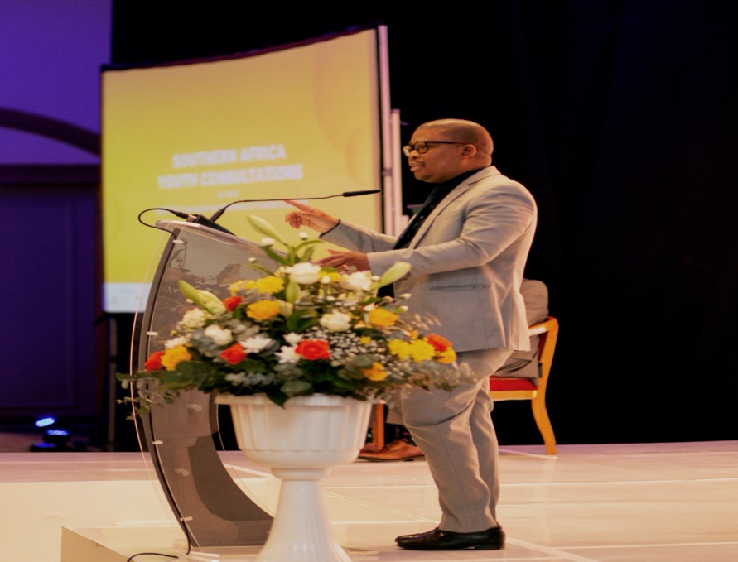

*Pastor Molutsi delivering a word of encouragement and opening Prayer.*

# 

# OPENING STATEMENT

**Hon. Emma Kantema-Gaomas, Deputy Minister of Sports, Youth and National Service, Republic of Namibia.**

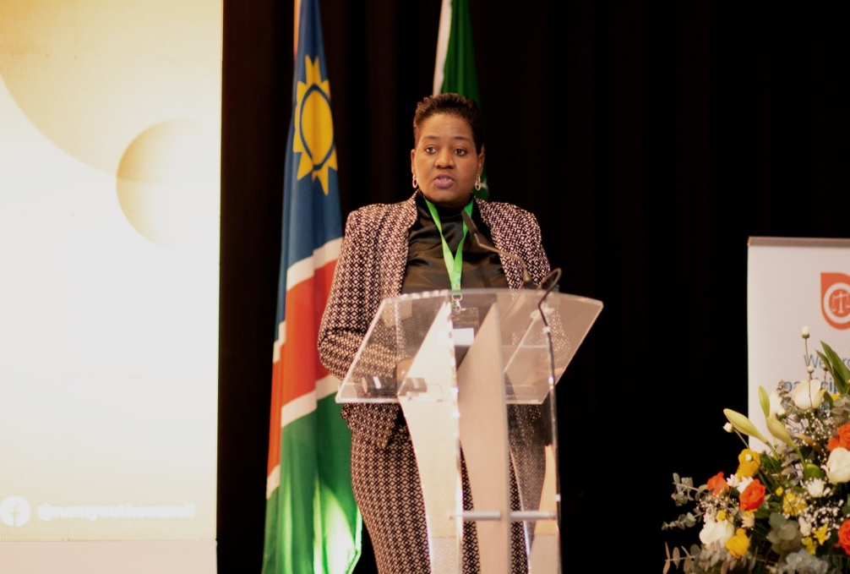

***Hon. Emma Kantema delivering her opening statement***

Good morning Ladies and Gentlemen.

It is an honour to deliver an Opening Statement at this Youth and Government Consultative Meeting on the African Continental Free Trade Area ( AfCFTA) Protocol on Women and Youth in Trade, under the theme, “*Promoting Equitable Youth Outcomes in the AfCFTA through Sustainable Domestic Resource Mobilisation and Allocation*.” Today, we gather to discuss what is undoubtedly one of the most significant economic developments on the African continent in recent times. The African Continental Free Trade Area represents a historic opportunity for African countries to boost intracontinental trade, drive economic growth, and create jobs for millions of people.

By now, many of us in the room must know the AfCFTA to be an instrument of regional integration on the African continent, through the gradual elimination of tariffs and other barriers to the intra-African trade of goods and services. We know that the single market of trade that the AfCFTA seeks to create has the potential to increase Africa’s income by 450 billion US Dollars by 2035 and increase intra-African exports by more than 81 percent. We know that the Agreement will address the excessively high trade costs and steep tariff barriers that stifle economic growth and undermine the continent’s overall development.

What may, however, not be so obvious is that the existing realities and nuances of our continent mean that the massive potential of the AfCFTA may not be readily available to women and youth, and that women and youth traders are less likely to be equipped with the appropriate skills, technology and resources to fully reap the fruits of the AfCFTA Agreement. Moreover, it is important to note that the youth will play a critical role in the success of the AfCFTA. With over 60% of Africa's population under the age of 25, young people represent a significant demographic and a key source of innovation, creativity, and entrepreneurship.

How can we say that we are fully embracing the AfCFTA Agreement when the largest demographic on the continent has limited participation in trade, business and entrepreneurship, particularly on an export-scale? The answer is: we cannot unless we take deliberate actions to eliminate the barriers such as the protocol on youth and women.

This is what makes this Consultative Meeting an absolutely necessary step in seizing the considerable opportunities that the AfCFTA has for using trade more effectively as an engine for inclusive growth and sustainable development.

I am pleased to see a room full of young people; youth entrepreneurs, youth policy makers and youth lawmakers and their enabling parties— convening to arrive at a better understanding of what is required at national and regional levels to build a continental environment in which young people and women can fully participate in trade and, ultimately, unlock the full benefits of the African Continental Free Trade Area.

In the same vain, I take this opportunity to take my hat off to our co-convening partners, the Ministry of Industrialisation and Trade, and the National Youth Council, and our supporting partners, the Youth for Tax Justice Network, the Delegation of the European Union to Namibia, the UNDP Namibia Office and the AfCFTA Continental Secretariat. Well done!

To our delegates from across the continent, thank you for honouring our invitations to this important Consultative Meeting. We are, indeed, ready for regional integration.

To delegates from within Namibia – whether you are an entrepreneur, an academic, an international trade enthusiast or a policy maker; let us use this opportunity to learn and engage, and to, through critical engagement, arrive at an outcome report that contains strong policy and programme recommendations that will inform the design of national policies and other measures to address and remove the factors that reduce women and youth’s participation in trade and business. The support of the Ministry of Sport Youth and National Service as well the Ministry of Industrialization and Trade and Industry is a testament to the government's commitment to realizing this potential and building a more prosperous future for all Namibians. Let us work together to explore how we can make the most of this opportunity and build a more prosperous future for all Africans.

This is our opportunity to build the Namibia, and the Africa that we want! May the consultative meeting start!!

Thank you.

# 

# KEYNOTE ADDRESS

**By Hon. Lucia Ipumbu, Minister of Industrialization and Trade, Republic of Namibia.**

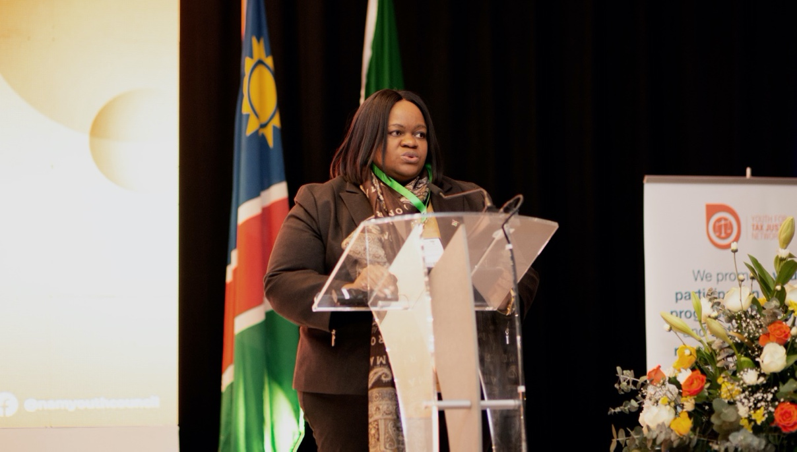

***Hon. Lucia Ipumbu delivering the keynote address***

Ladies and Gentlemen, Good morning,

It is my great pleasure to welcome you to this very important event, the African Continental Free Trade Area-Southern Development Community Regional Consultation, on the ‘Protocol on Women and Youth in Trade and E-Commerce’. I would like to express my deepest appreciation to you all for honoring our invitation and participating at this event. I also wish to extend my appreciation to the Office of the President and Ministry of Sports, Youth & National Service for playing a leading role in coordinating this forum, as well as to our Partners - the Continental Secretariat, Youth for Tax Justice Network, UNDP Namibia and EU Delegation to Namibia for contributing towards the convening of this regional workshop in the Republic of Namibia. This is a demonstration of the Namibian Governments’ unrelenting commitment to cascading and domesticating the AfCFTA towards its successful implementation and to ensure that the voices of women and our young people are effectively mainstreamed into the formulation of this transformational framework.

The African Union theme for 2023 shines the spotlight on “Accelerating implementation of the AfCFTA”, a theme that echoes the continental consensus that the future of Africa lies in greater investment and intra-Africa trade through reduced tariffs and freer movement of peoples and goods. This focus is timely because our large demographic majority of youth and women are at the centre of realizing our regional and continental economic integration agenda. We therefore, simply cannot afford to leave them behind.

The Agreement establishing the African Continental Free Trade Area recognizes the role of women and youth in trade and the importance of empowering them to fully participate and benefit from the African Continental Free Trade Area Agreement. To this end, the ‘Protocol on Women and Youth in Trade’ as well as the ‘Protocol on Digital Trade’ are being developed. Through these Protocols, women and youth can play a critical role in the achievement of the free trade zone by initiating youth-led initiatives particularly, in agriculture, financial services, and information technology and in the creative industries.

Women and youth face challenges in trading across borders and are confronted by many barriers to trade such as complex export procedures, intimidation; extortions and harassment at borders. I believe the Protocol on Women and Youth in trade should address the persistent challenges faced by women in trade and provide solutions in terms of better border governance and trade facilitation. This consultation should make recommendations that will lead to state parties to implement necessary instruments at national level that will lead to the removal of all constraints impeding participation of women and youth in trade and also recommendation on how E-Commerce could enhance continental trade in general.

Namibia as a state party to the AfCFTA Agreement and her offer within the SACU configuration has been adopted by the Council of Ministers, both in trade in goods as well as in trade in services and is therefore ready to champion initiatives that target women and youth participation in key sectors such as agriculture, manufacturing logistics and tourism.

In that regard, Namibia has identified key sectors where women and youth have a competitive advantage, such as agriculture, aquaculture, cosmetics sector, textiles etc. The Ministry of Industrialisation and Trade concluded the first ever training on standards with focus on a Good Manufacturing Practices that targeted more than 30 cosmetic companies at the beginning of September 2022.

The Cosmetics and Essential Oils sector has advanced in terms of production domestically and thus participation in the regional value chain is possible. For example, our exportable firms increased from 5 in 2016 to more than 35 by 2022 through concerted efforts by the private sector, Namibian government and development partners.

At SADC level, Namibia has prioritized sectors for value chain development namely; Agro processing (leather processing), Pharmaceutical, Automobile, Mineral beneficiation and Tourism. Namibia has the Northern tannery which is currently under-utilized and thus it will be great to optimize the usage of this tannery and produce hides and skin for value addition.

Regional Value Chains are part of Namibia’s Industry Growth Program which is part of the ongoing efforts to reinforce Namibia’s economic growth, to reduce income inequality and to increase employment for its citizens. This Industry Growth Strategy forms part of the support to selected manufacturing industries envisaged by the Growth at Home Strategy, which promotes Namibia’s competitive advantages and opportunities. This is envisaged through the Special Industrialisation Programme whose aim is to provide targeted support for value chain analyses.  These are collaboration efforts under the SADC Industrialisation Strategy (2015-2030), within the Support to Industrialisation and Productive Sectors (SIPS) Programme, which is supported by the European Union (EU) for the Secretariat of the Southern African Development Community (SADC).  The Programme addresses coordination and linkage gaps and opportunities between the regional and national levels, between the public and private sector and between the private sector in SADC Member States (MS), with a specific focus on the leather and associated value chains in the agro processing sector and associated value chains in the pharmaceutical sector.

Cross-border value chains are a critical component of “Growth at Home”. By leveraging comparative potential with its neighbours, the government seeks to involve both development financing institutions and the private sector to create self-sustaining industries. A study commissioned by Namibia’s Joint Value Addition Committee recommends initiating cross-border contacts within SADC to review opportunities for cooperation to improve beneficiation in a number of minerals such as in diamonds, iron ore and zinc, Lithium both for supply chain and marketing purposes.

This workshop should therefore, discuss and identify issues for inclusion in the Protocol on Women and Youth in Trade and E-Commerce, as well as to enhance access to economic opportunities for the youth at national and regional levels through sustainable youth priority sectors. The specific objective of the workshop will be as follows:

* To build skills and knowledge of the youth on key AfCFTA processes at national and regional levels;
* To inform the negotiations on the AfCFTA protocols on Women and Youth in Trade and E-Commerce;
* To brainstorm and share information on gaps and opportunities for the youth in the AfCFTA process and how these can be harnessed; and
* To foster deeper awareness of the challenges that youth entrepreneurs, producers and traders face when engaging in intra-regional trade and how these challenges can be effectively addressed.

It is hoped that networks and business collaboration will be forged and strengthened. To this end, ladies and gentlemen, stakeholder engagement and information sharing continues to be very important to the successful development of the protocols on Women and Youth in Trade and E-commerce. We recognize the importance of all stakeholders as key contributors to the AfCFTA developmental agenda and as part of the solution.

In the area of E-Commerce, digital technologies and appropriately tailored rules for the digital economy, the Protocol on Digital Trade presents a unique opportunity for Africa to achieve digital and financial inclusion, and to enhance digital innovation. In this regard, the African Continental Free Trade Area Secretariat has developed a call to action for Digital Financial Inclusion in collaboration with Smart Africa Alliance and the UN-based Better Than Cash Alliance to ensure that every African has the tools and financial services that enable them to make payments seamlessly in the one African market.

It is time to be deliberate and be intentional in our approach for implementation policies and programs that enable women and youth to leverage on available trade opportunities and to become masters of their own destinies.

***The outcomes from this consultation will be submitted to the Continental Secretariat to further inform the finalization of these important Protocols. The SADC Youth Voice is important in this process. Your Voice is important to us and we want to negotiate, in your best interest.***

Let me therefore implore on all of us to use this platform to emerge with concrete plans of action and make actionable recommendations that will inputs in the development of the afore-mentioned protocols.

With these few remarks, I wish you all a fruitful deliberation.

I thank you.

# PARTNER REMARKS

**Mr. Allan Muhereza Murangira, Team Leader, Youth for Tax Justice Network**

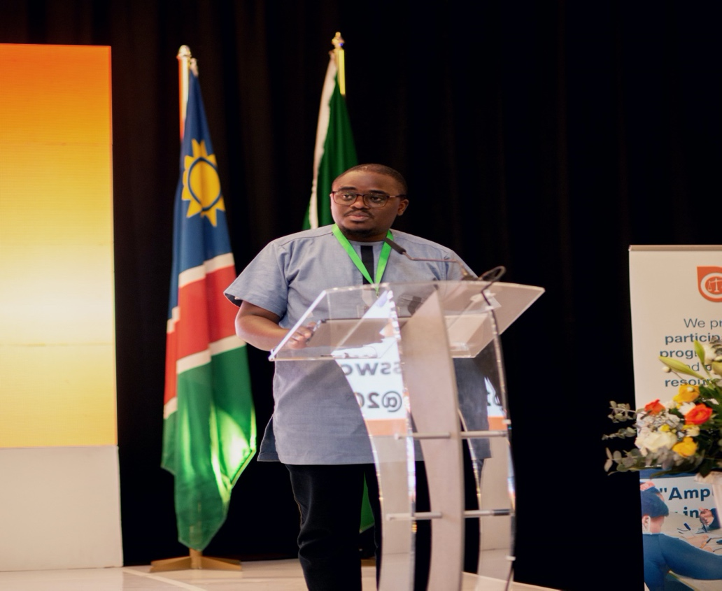

*Allan Muhereza delivering his remarks*

Colleagues, fellow young people.

Greetings from the Youth for Tax Justice Network, a Pan African Youth Organization working towards meaningful youth participation in influencing decision making on resource mobilization, allocation and utilization for the benefit of youth in Africa. We are based in Kampala Uganda but do work in East and Southern Africa.

It’s my singular honor to be with you all today, in this beautiful land, for this very important youth consultative meeting aimed at gathering opinions to inform the ongoing negotiations of the AfCFTA Protocol on Youth and Women.

The 2017 African Union theme was "harnessing the demographic dividend through investment in youth" which is still relevant to this year’s theme of acceleration of AfCFTA implementation. Investment in Youth requires resource to create the right environment for youth to participate in trade.

The Futures report recognizes that, beyond the numbers and negotiations, the realization of this promise will depend on decisive actions and the collective efforts of the African people. Concrete policy measures and investments are needed, in particular to ensure that women and youth, who account for the majority of the population, business owners and workforce, can be better integrated into the value chains, jobs and opportunities stemming from the AfCFTA.

The coloration between trade and resource mobilization cannot be ignored. That for youth to meaningfully participate in trade, states have to domestically raise resources in ways that are not detrimental to young people, invest them in priority sectors

We are having this consultative meeting at a time when African youth are dealing with and simultaneously responding to multiple crises like the Shocks of the COVID-19 pandemic, Climate Change induced loss and damage, the restrain public debt financing is putting on our social sector budgets, global value chain disruptions due to the ongoing Russia-Ukraine war. What this means is that African States require vast amounts of resources to adequately respond to these crises in addition to investing in key sectors that are critical to improving youth livelihoods.

Youth For Tax Justice Network started works around AfCFTA in 2021 under our Youth Economic Empowerment Program which aims to enhance meaningful youth participation in trade at a national and regional level. In partnership with the Government of the Republic of Uganda through the Presidency through the Senior Presidential Aide Incharge of Youth Affairs, the Ministry of Gender, Labour and Social Development which is the Line ministry for youths, the Ministry of Trade and Industry, and the National Youth Council, the Youth for Tax Justice Network undertook consultations on the AfCFTA protocol on youth and women under the theme: Promoting Youth Equitable in the AfCFTA through sustainable resource mobilization and allocation.

In April 2022, the outcome of these consultations for the East African Region was validated and commissioned in Uganda. In September 2022, the Youth For Tax Justice Network formed part of Ugandan Delegation to the Inaugural AfCFTA Conference on Youth and Women in Dar -es salaam led by Her Excellency the Vice President of the Republic of Uganda, where the outcomes of that consultation was presented and discussed with the AfCFTA Secretary General Wamkele Mene who welcomed the report.

In the same November, we were approached by Mrs. Daisry Obal to in partnership with the Republic of Namibia host a Southern Africa Youth Consultation on the Protocol on Youth and Women in the Republic of Namibia. In recognizing the commitment of the President of the Republic of Namibia H.E Dr. Hage Geingob towards meaningful and inclusive youth development, and in recognizing of the amazing works at national and even continental level of Mrs. Daisry Obal and the Namibian National Youth Council, the Youth for Tax Justice Network accepted and was able to put together considerate resource envelope to ensure that the young people of Namibia and by extension Southern Africa is consulted. In undertaking this consultative meeting, the Government of the Republic of Namibia has distinguished itself as one that is open, accommodative and walking the talk on involving young people in making the decisions that matter.

Ladies and Gentlemen, there is no doubt that the AfCFTA is a game changer. It has come to revolutionize how businesses are conducted in the continent. The success of this important trade Agreement solely lies in its ability to be received and understood, owned and implemented by and with the young people. What we will be doing here today and tomorrow will undoubtedly shape the future of AfCFTA in the continent.

Through its protocol on youth and women, the AfCFTA is positioning itself to unlock the future of African Youths through innovations, migrating informal industries to formal industries, encouraging domestic resource mobilization, cross border trade and service provision, financing and payment system among others.

In view of this, we at Youth for tax justice network are happy to have supported and continue to support the Republic of Namibia to engage in these kinds of important deliberations. The outcome of this meeting will inform our final report to the AfCFTA secretariat to inform this important youth protocol.

I would like to wholesomely thank the Government of the Republic of Namibia and all its Development Partners, and all the young people here for your commitment to championing important continental aspirations.

I wish as all meaningful deliberations these two days.

OVERVIEW PRESENTATION: AFCFTA FRAMEWORK & PROTOCOL ON WOMEN & YOUTH IN TRADE

By Ms. Ndiitah Nghipondoka-Robiati, Deputy Executive Director, Ministry of Industrialisation & Trade, Republic of Namibia.

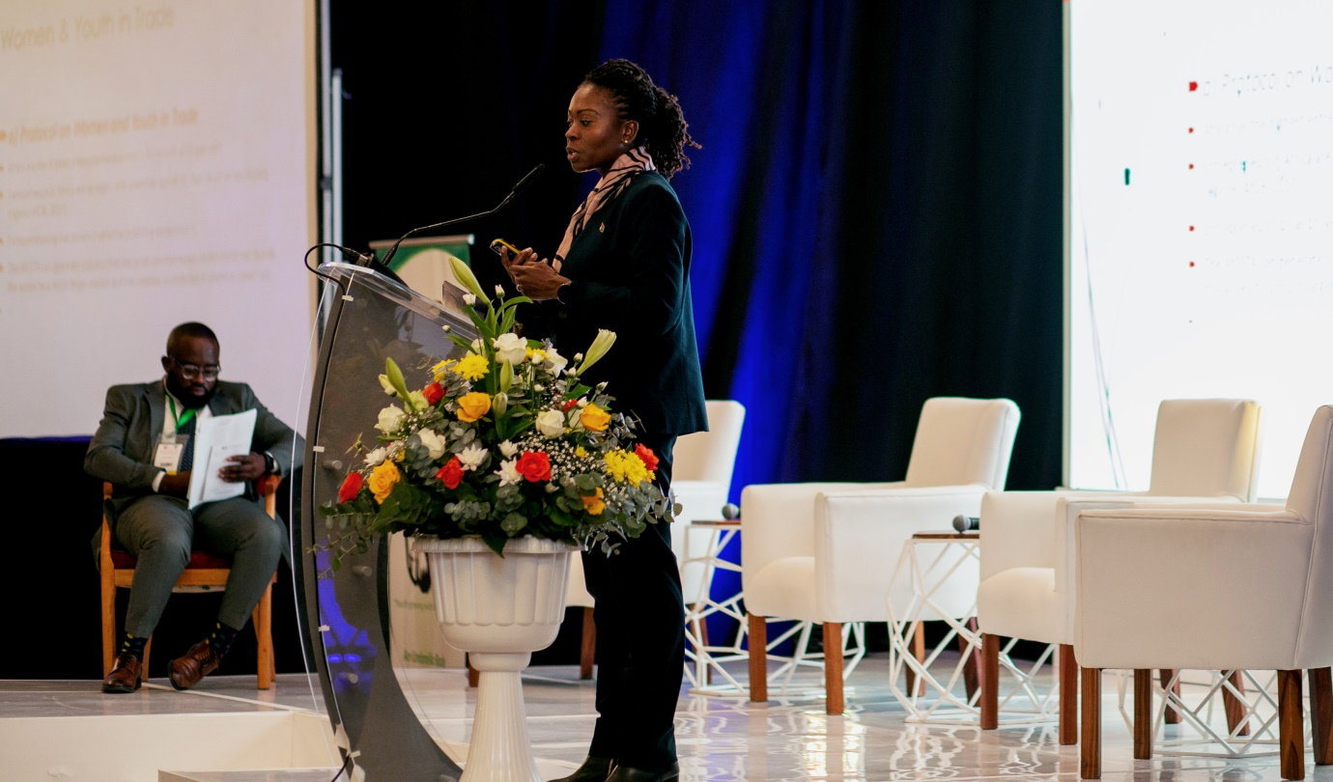*Ms. Nghipondoka-Robiati delivering her presentation*

She stated that the mandate of theMinistry of Industrialization & Trade of the Republic of Namibia is the development and implementation of appropriate policies and legal frameworks to improve ease of doing business, attract investment, increase trade and develop and expand the country’s industrial base. She made a comparison between Africa’s land area to selected countries/regions. She informed the audience that Africa covers an area of 30.4km while Russia covers an area of 17.1km, United States of America covers an area of 9.8km, China covers an area of 9.6km, Brazil covers an area of 8.5km, Europe covers an area of 5.9km and India covers an area of 3.3km.

She further informed the audience that Import/export procedures in Africa involve an average of 20 to 30 different parts, 40 documents, 200 data elements. That Africa has high transport costs (63% higher than in DC and 135% higher than in Europe. That the average cost of freight as a % of the total value of imports is around 11.4% for Africa versus 6.8% for Developed Countries.

She thereafter brief explained what the AfCFTA is. That it is the largest free trade area since the creation of the WTO (by number of participants). It contains 55 countries, 1.3 billion people with a combined GDP of $3.4 trillion. Its key tools are tariff reductions on most tradable products, liberalization of trade in services, Clear rules of origin and identification of non-tariff barriers. She emphasized that AfCFTA’s aim is to create one African market.

She went ahead and explained the history and origins of the AfCFTA. From the creation of the Organization of the African Unity (now known as the African Union), to 1980 when the Lagos Plan of Action for the Economic Development of Africa (1980-2000) was formulated, to 1991 when the Treaty establishing the African Economic Community was promulgated and finally to 2018 when the agreement establishing the African Continental Free Trade Area was signed by 44 countries and in 2019 when it was signed by a total of 54 countries.

She further presented the objectives of the AfCFTA to include creating a single market for goods, services, facilitated by movement of persons in order to deepen the economic integration of the African continent and in accordance with the Pan African Vision of “An integrated, prosperous and peaceful Africa” enshrined in Agenda 2063; Create a liberalised market for goods and services through successive rounds of negotiations; Contribute to the movement of capital and natural persons and facilitate investments building on the initiatives and developments in the State Parties and RECs; lay the foundation for the establishment of a Continental Customs Union at a later stage; Promote and attain sustainable and inclusive socio-economic development, gender equality and structural transformation of the State Parties; Enhance the competitiveness of the economies of State Parties within the continent and the global market; Promote industrial development through diversification and regional value chain development, agricultural development and food security; and Resolve the challenges of multiple and overlapping memberships and expedite the regional and continental integration processes.

She then gave an illustration of the overlapping memberships in subregional trade agreements such as East Africa Community, Economic Community of Central African States, Common Market for Eastern and Southern Africa, Intergovernmental Authority on Development, Economic Community of Western African States and so on.

She then explained how the AfCFTA tools are used. That is by:- progressively eliminating tariffs and non-tariff barriers to trade in goods; Progressively liberalising trade in services; Cooperating on investment, intellectual property rights, competition policy, on customs matters and the implementation of trade facilitation measures and other trade-related areas; establishing a mechanism for the settlement of disputes concerning their rights and obligations; and establishing and maintaining an institutional framework for the implementation and administration of the AfCFTA.

She highlighted some of the expectations from the AfCFTA to include creating a bigger and integrated regional market for African products; permitting producers to benefit from economies of scale and to access cheaper raw materials and intermediate inputs; improving conditions for forming regional value chains and integrating into global value chains; giving consumers access to cheaper imports from other African countries; better allocation of resources and faster economic and trade growth; catalysing the structural transformation of countries from resource-and low-technology-based economies to more diversified, knowledge-based economies; encouraging both intra-African and external direct capital flows to African countries; stimulating cooperation in other areas such as technology transfer, innovation, investment and continent-wide infrastructure development.

She then took through the audience the status of negotiations and implementation of the AfCFTA as follows.

***Schedule of Tariff Concessions***

* *(list of negotiated specific tariff concessions and commitments by each State Party)*
* Level of ambition of 97% tariff liberalization over a specified period of time = 3% Exclusions
* 43 African countries have submitted their Offers to the AfCFTA Secretariat
* 4 Customs Unions have submitted Tariff Offers: CEMAC; EAC; ECOWAS and SACU
* 29 initial Tariff Offers have been technically verified and are certified to be ready to commence trading under AfCFTA preferences
* Technical verification continues on the remainder of the initial offers to ensure that they are Summit-modalities compliant.

***Rules of Origin***

* (criteria used to define where a product was made)
* 87.8% of the tariff lines have been agreed upon under the RoO negotiations
* 12.3 % of the tariff lines under the RoO negotiations are yet to be agreed upon:
* Provisional application of RoO in existing trade regimes of RECs, pending the adoption of all outstanding issues in the RoO negotiations (CoM).
* Technical work around the outstanding rules to be continued to be a built-in agenda with aim of finalization in September 2022.

She then took through the audience the implementation status of the trade in services as follows:-

* 46 African countries have submitted their Services Offers
* Technical verification to ensure that offers are in line with the adopted modalities and Guidelines for Negotiating Trade in services under the AfCFTA and regulatory audits for some Member States
* Negotiations on submitted offers in the 5 priority sectors have been carried-out in four Dedicated Sessions (Business Services, Communications, Financial Services, Tourism and Transportation)
* Extension of the deadline for completion of the services negotiations in the 5 priority sectors to 30 June 2022 (CoM decision endorsed by the Assembly).
* Outstanding Issues: Negotiations to commence on the remainder of 7 Services Sectors and regulatory frameworks

She then discussed the phase two of the AfCFTA negotiations where she spoke about the justification for the *Protocol on Women and Youth in Trade as follows:-*

* Africa has the highest entrepreneurship rate in the world, at 22 per cent;
* Entrepreneurs in Africa are younger, with a median age of 31, than in other developing regions (AfDB, 2017);
* Entrepreneurship has proven fruitful for providing employment;
* The AfCFTA can generate opportunities for youth entrepreneurs on the continent though the access to a much larger market and the creation a conducive business environment.

She went ahead to explain the status of women and youth in the AfCFTA. Article 3(e) speaks to promoting and attaining sustainable and inclusive socio-economic development, gender equality and structural transformation of the state parties. Article 27 (2) (d) of the Protocol on Trade in Services mandates state parties to improve the export capacity of both formal and informal service suppliers with particular attention to micro, small and medium size; women and youth service suppliers. She further pointed out that 80% of businesses in Africa are categorized as small and medium sized enterprises, the informal sector accounts for more than 85% of economic activity in Africa. Women account for nearly 90% of the labour force in the informal sector.

She then discussed the status of Namibia in light of the implementation of the AfCFTA as follows:-

* + Today, the value of trade as a portion of Namibia’s GDP is relatively high, averaging nearly 97% between 2013 and 2018, a rate considerably higher than that of the region’s dominant economy, South Africa, which, at 59%, nearly matches the 2018 global average, which is around 60 percent.
  + Namibia has long been a net importer of goods and services, with a trade deficit over the past decade ranging from N$842 million in 2010 to a peak of 41,058 million in 2015.
  + Namibia’s exports are dominated by raw materials and intermediate goods, which constitute around 80% of the export basket, with capital and consumer goods taking up around just 20% of the export basket.
  + Conversely, Namibia’s imports are dominated by capital and consumer goods (around 64%) with the balance consisting of intermediate goods and raw materials.

She summarized her presentation by speaking to the readiness of Namibia to implement the AfCFTA. She said that Namibia had already signed and ratified the agreement and submitted the offer through SACU. That the next steps is the technical verification process and continuing to negotiate the outstanding issues.

HIGH-LEVEL PLENARY

Accelerating Implementation of the AfCFTA: Overview on the Protocol on Women And Trade In Trade.

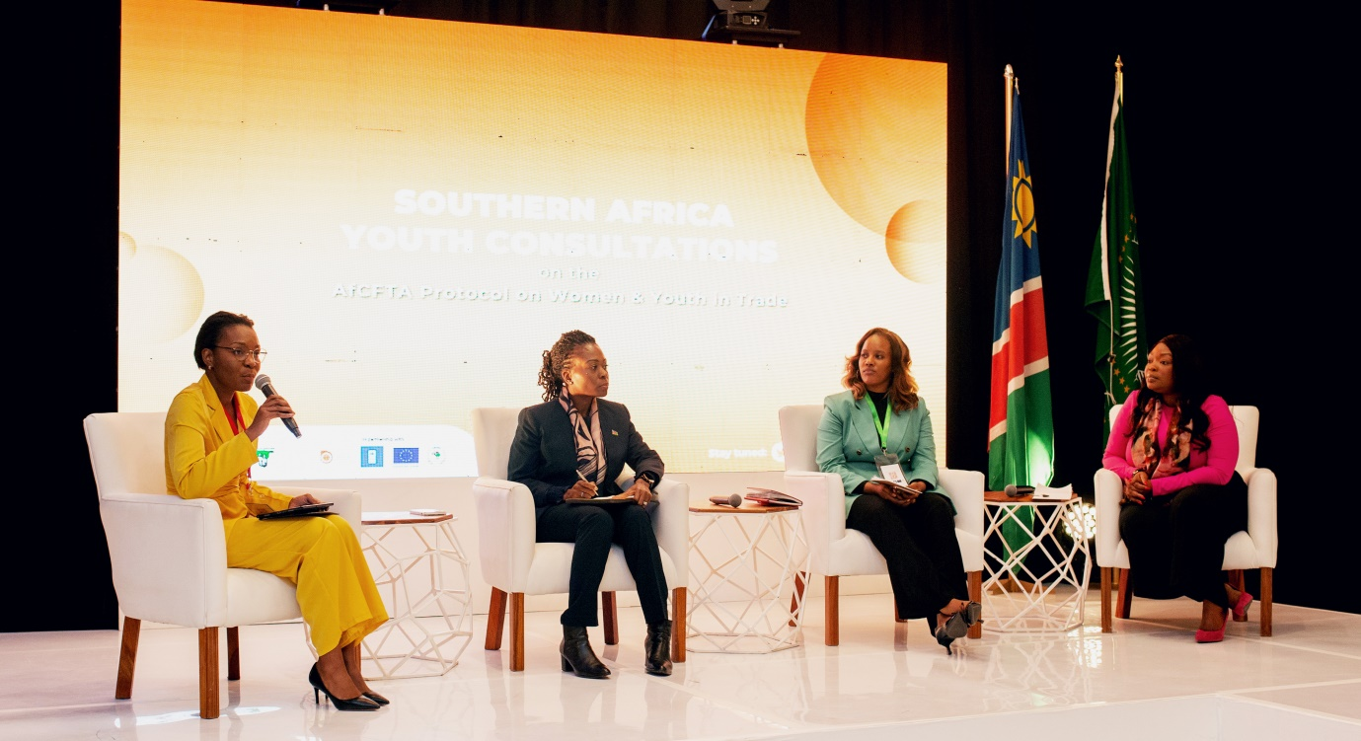 *L-R: Daisry Obal, Ndiitah Nghipondoka-Robiati, Gonaya Monei & Stacey Susa-Pinto*

**Moderator**: Ms. Daisry Obal, Presidential Advisor: Youth Matters and Enterprise Development, Office of the President, Republic of Namibia

**Panelists:**

1. Ms. Gonaya Monei E. Sethora, AfCFTA Continental Secretariat.
2. Ms. Ndiitah Nghipondoka-Robiati, Deputy Executive Director, Ministry of Industrialisation & Trade, Republic of Namibia.
3. Ms. Stacey Susa-Pinto, Chief Executive Officer, Namibia Trade Forum.

Ms. Gonaya Monei took the audience through the process of negotiating the Protocols of Women and Youth in Trade and E-commerce and the AfCFTA and also shade some light on the way forward. She said that at the 13th Extra-ordinary Summit of the Heads of State in 2020, the Presidents made a commitment to broaden the scope of the Africa Continental Free Trade Area and include young people, women and small medium enterprises. In 2022, the Heads of State agreed to promulgate a Protocol for Women and Youth in Trade. She said that young business people find it difficult to get collateral and the Protocol seeks to solve this problem. She said the Secretariat held its first consultations on the Protocol in Kenya and then they took the discussions to Tanzania in 2022 where youth and women traders. She also emphasized that the Secretariat is aware that women and youth in trade face different challenges and they will endeavor to solve them while negotiating the Protocol on Women and Youth in Trade.

Ms. Stacey Susa-Pinto encouraged young people and women to take advantage of forums such as this one to advance their interests in trade. She said that the Trade Forum makes it intentional to meet the young and female traders in the private sector to understand their problems and help them. She added that business is dynamic and women and youth in trade do what they have to do to survive. On the issue of how women and youth in trade can benefit from this protocol, she encouraged policy makers to understand how young people and women in trade operate and help them make policies which suit their mode of operation and add value to it. On the issue of informal trade, she said that over most informal trades are young women and youth.

## Audience response

**Pedro**, a law student from Namibia said that he is doing research around the AfCFTA. He noted that the main actors in this agreement are the citizens of the partner states. He also noted that the rules of contract in Anglophone countries differ from those in francophone countries. He then asked how conflicts arising from traders from these two different blocks will be resolved.

**Thoneke** a radio producer and an investigative journalist was grateful to be part of this historic meeting. She asked whether we have the policies and laws to ensure that young people are empowered to become successful business people.

**Thompson Qwala** said that he was representing the Namibian youth, SADC Youth and African youth. He asked what currency partner states are going to use to trade.

## Call to action

* Ms. Pinto encouraged women and youth in trade to use social media a tool to boost intra-regional trade.
* Policy makers need to understand how young people and women in trade operate and help them make policies which suit their mode of operation and add value to it

# SESSION 2

**Mainstreaming Africa’s Women and Youth In Trade: Challenges & Opportunities**

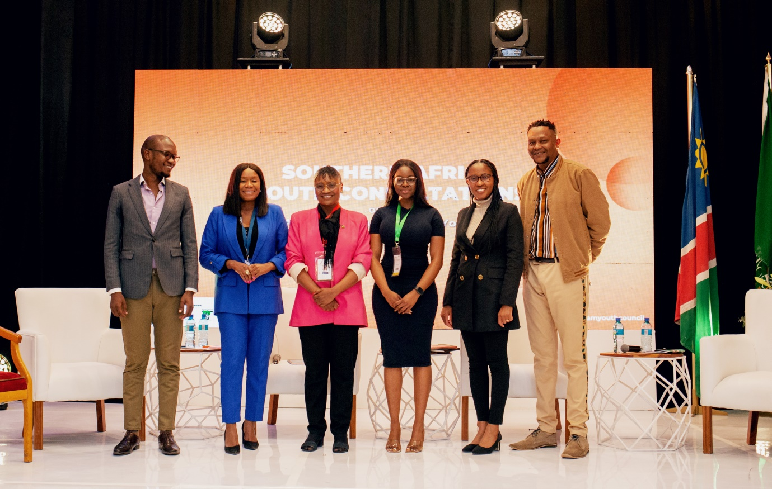*L-R: Emolot David, Omagano Kankondi; Maria-Lisa Immanuel (Moderator); Bertha Tobias; Emilia Uupindi; Patrick Sam*

The session addressed the necessity of the protocol in addressing the needs and challenges faced by women and youths in trade. Some of the key areas of discussion included the principles of pan Africanism, the need to ensure easier cross border trades, and the opportunities and programs that finance institutes have for women and youths at the grass root levels in entrepreneurship.

**Moderator:** Ms. Maria-Lisa Immanuel, Trade Economist, Republic of Namibia

**Panelists:**

1. Mr. Emollot David, Chairperson, AfCFTA Youth Advisory Council, Tanzania
2. Mr. Patrick Sam, Managing Director, Creative Culture Investments, Namibia.
3. Ms. Omagano Kankondi, Accelerator Labs, UNDP Namibia
4. Ms. Emilia Uupindi, Manager Trade, Business & Commercial Banking, Standard Bank Namibia

The following were the key discussion outcomes by the panelists;

**Mr. David Emolot**

Overtime, the campaign of dividing women and the youth has been there from the very beginning. The campaign is based on the fact that women are very vocal and can overshadow the youth. The Secretariat is taking deliberate efforts to create platforms where these two groups get to discuss their issues independently, and then come on the table and form the AfCFTA protocol for women and youths in trade. Giving these two groups their independent platforms is quite vital.

On the mainstreaming of youths in the AfCFTA processes, there are deliberate exclusions of youths in the implementation processes. These exclusions start from the consultation process, where the youths are not engaged. Our governments acknowledge the youth as the majority, but besides that there is no evidence to show that the youths are being mainstreamed.

The AfCFTA is that one agreement that has clear frameworks tailored to mainstream the youths. There is need to include the youths from all sectors, engage them in the implementation process from the start.

Moving forward, the strategies that the government is developing should have a youth perspective to it, even the implementation of the AfCFTA; the youths should be at the fore front of the drive.

Attention should be paid to e-commerce as one of the areas that directly affect the youth and as one of the platforms on which youth trade currently.

Lastly, on meaningful youth engagement, there is a need to have youth desks at the cross borders points and airports for trade. The bigger majority of the youths are semi illiterate or illiterate. It will ease trade and enable the youths smoothly participate in cross border trading.

**Mr. Patrick Sam, Managing Director, Creative Culture Investments**

Young people need to learn and appreciate the value of African cultural products. Currently African cultural products constitute less than 1% of the total global trade on cultural products. This is because the youths do not appreciate the value of African cultural products; they think it is *uncool*.

The conversation about AfCFTA, there should be a discussion on the right to imagine, the right to create, to distribute, produce and consume African cultural products in business and trade.

**Ms. Omagano Kankondi**

On how women and youth traders can benefit from the UNDP, they have to ensure that their works are human centered in approach; the labs are not traditional incubation platform, but one that exists to accelerate learning.

However, a hindrance to trade for women and youths is corruption at the borders, lack of accountability from the officials at the borders, bureaucracy and other obstacles. This makes it impossible for women and youths to grow from their efforts in terms of profit realization.

**Ms. Emilia Uupindi**

One of the key challenges faced by women and young people in trade is access to finance and access to bigger markets, because these are all part of the trade chain.

When it comes to trade finance, From a Namibian perspective, the traditional bank institutions have had to reinvent themselves to incorporate how to finance particular SMEs and the challenges that come with that, and also our government has been part of this; whereby SMEs can now borrow money from banks with a 95% collateral paid for by the government.

The challenge herein is that women and youths in trade hardly have access to this information, and that hinders their ability to take advantage of these opportunities.

## Audience Response

* Are there provisions in the AfCFTA protocol that speak to visa provisions in line with cross border trading?
* There is a need to be cautious about the increase in crime rates when the borders are opened up for trade.
* Government should create an enabling environment for SMEs and the informal sector generally to benefit from the protocol.
* What is the banking sector doing to ensure that grass root entrepreneurs benefit from their programs?
* There is a need to ensure that the protocol includes provisions for persons with disability to access and benefit from it.
* The youths need to dream big and take initiative in their growths and development.
* Are there investments and provisions in the protocol that speak to health care?

## Call to Action

* There is a need for SMEs to be registered so that they can benefit from the available programs from the government and finance institutes particular to the needs of the SMEs.
* Inclusive procurement is a method that should be adopted to ensure that programs adhere to the principle of inclusivity of women and youths with disability. Inclusivity is key to the development of Africa as a continent and this solution will ensure that all programs are disability sensitive.
* Research and development should be encouraged. There is need to have this aspect in policy development.
* The narrative of valuing property and materials over people needs to change, so that all programs can enhance human dignity.
* The pan African needs to be encouraged; having the interests and love for other people at heart. When children are nurtured to understand this, Africa will go forward. The AfCFTA is going to ensure promotion of economic and political integration, to ease trade. Youths should urge their governments to sign and ratify this protocol.
* There is a need to have a gender responsive budgeting. This enables states to address the issues that women go through, and provide solutions accordingly.

# SESSION 3

**Legislative and Policy Perspective: Promoting Equitable Youth Outcomes in the AfCFTA through Sustainable Domestic Resource Mobilisation and Allocation.**

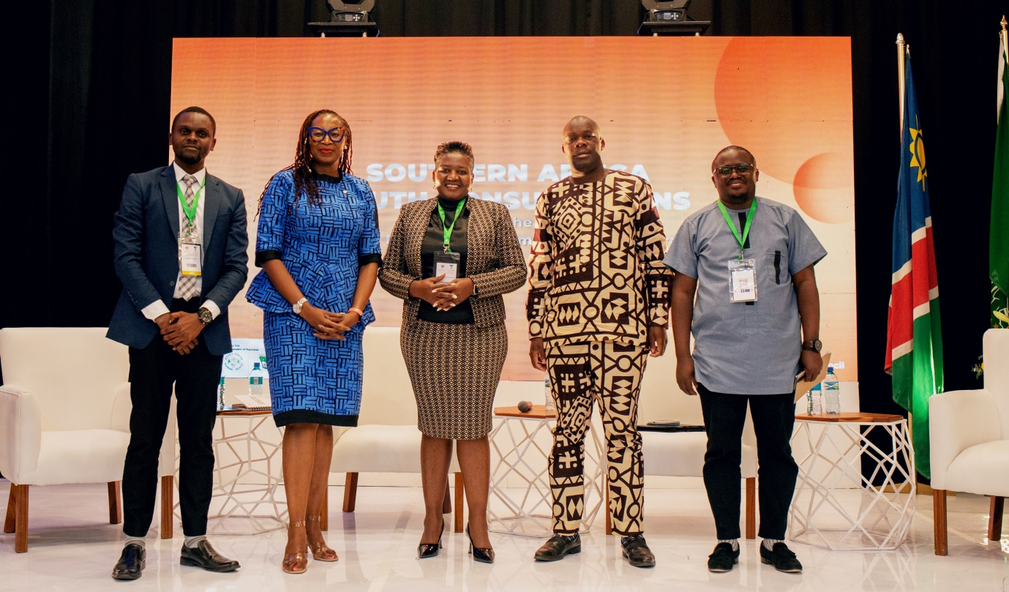***L-R Jon Kafuko, Iruka Ndubuizu, Hon. Emma Kantema-Gaomas, Hon. Ephraim Nekongo, Allan Muhereza***

**Moderator:** Mr. Jon Kafuko, Programs Manager, Youth for Tax Justice Network.

**Panelists:**

1. Hon. Emma Kantema-Gaomas, Deputy Minister of Sports, Youth & National Service, Republic of Namibia.
2. Ms. Iruka Ndubuizu, Director of Partnerships, Tony Elumelu Foundation.
3. Mr. Allan Murangira, Youth for Tax Justice Network.
4. Dr. Misheck Gondo, Southern African Youth Forum Regional Coordinator.
5. Hon. Ephraim Nekongo, Member of Parliament, Republic of Namibia

The following were the discussion outcomes from the panelists;

**Hon. Emma Kantema- Gaomas** **Deputy Minister of Sports, Youth & National Service, Republic of Namibia.**

Firstly, the reason for this discussion is a step in the direction on how and where governments’ prioritize the AfCFTA protocol. Government has realized that entrepreneurship is one way to promote and create jobs and reduce the burden of unemployment. The Protocol aims to achieve intra-trade and Namibia has already gone ahead to start working on how to domestic the free trade agreement.

Sports can be positioned into this AfCFTA, especially since we already have African youths flourishing on the global platforms. This can be a big value chain everyone can participate in, from sports equipment, broad casting rights and this can enhance the promotion of employment and trade for women and youths.

**Ms. Iruka Ndubuiza, Director of Partnerships, Tony Elumelu Foundation, Federal Republic of Nigeria**

Dispute resolution provisions in the protocol are specific to State Parties. It does not include the young people and women who are trading. This is part of the issue/challenge in the protocol, because it does not take into account the key parties in the dispute. Firstly, not all traders will be able to go to their governments in cases of conflict, and the chances of the start prioritizing resolving it is not guaranteed. The provisions have to be amended to enable parties that are center and primary to the dispute to partake in solving it.

Furthermore, the implementation of the protocol ought to be done with an African mindset, paying attention to the different needs of women and youths; in so doing the impact of the AfCFTA will be realized.

**Hon. Ephraim Nekongo, Member of Parliament, Republic of Namibia**

On agriculture, Africa has a very big market of about 1.93 billion people, and all these people need to be fed. The potential to dream about providing food for this entire people is a key in Africa becoming successful. However, there are challenges farmers are facing around climate change. This calls for a unique way of carrying out agriculture; smart agriculture and innovations that combat climate change is the way to move. Climate change in itself brings more challenges such as flooding and drought, and this is an opportunity for young people to bring solutions and innovations to tackle them.

**Mr. Allan Muhereza Murangira, Team Leader, Youth for Tax Justice Network**

In 2015, a survey was done around Africa’s ability to finance their needs, and that report stated that Africa loses about 50 billion US dollars per year in illicit financial flows. That for every dollar Africa makes, it loses about 3 dollars in return. Africa’s ability to raise resources was significantly affected by the COVID 19 period. Africa ought to invest resources in young people. The AfCFTA champions the investing of resources in allowing young people to participate in trade.

Currently, the dilemma is the removal of tariff barriers vis-à-vis creating an enabling environment for young people to participate in trade. However, there is need for State parties to ensure that tariff barriers are removed to allow young people to participate, and the solution is with harmonization of financial incentives to prevent states from competing in terms of attracting foreign direct investments. The draft protocol proposes giving tax incentives to youth and women led SMEs, and as such harmonization will be key in ensuring regulation of the incentives.

**Dr. Misheck-Gondo, Southern African Youth Forum Regional Coordinator**

On meaningful youth participation, there must be effective inclusion beyond just the concept of making youths beneficiaries of programs. Young people must be empowered to partake in discussions, production, access to technology, land and labor and this is when we can see young people actively participating and engaging in trade, as empowered individuals.

The barriers youth and women face are not homogenous, they are legislative, technical and all these aspects need to be addressed to achieve effective youth participation.

## Audience Response

* There is ineffective dissemination of information when it comes to AfCFTA. The people who need the information are at the grass roots and do not have access to such spaces, discussion and consultations. We must communicate in such a way that even the illiterates have access to the protocol.
* There is a need to introduce programs that will train each and every one to be able to take advantage of the opportunities in the AfCFTA protocol. This will allow for equal access to markets for both masterminds and the lay person.
* The requirements by banks to finance agricultural ventures for women and youths are still a barrier to accessing these opportunities. The collateral required by the finance institutes cannot be afforded by young people.
* There is a need to hold ministers and government officials accountable who get funds in the name of youth programs. They ought to keep their promises and bring these opportunities for youths.

## Call to Action

* Our manufacturing base has to be widened and the states need to increase their ownership percentage of the natural resources.
* There is a need to harmonize financial incentives granted to MSMEs in the draft protocol on Women and Youth in Trade to avoid State Parties losing resources through foreign direct investment.
* Such consultations ought to be taken to rural areas, to ensure that the target groups are reached with the right information; this will ensure raising awareness about the protocol to allow women and youths take advantage of it.
* There is a need to create a platform that listens to the voice of everybody that will be affected by the protocol.

# SESSION 4

**Protocol on Digital Trade: Leveraging Digitalization for Trade and Employment Creation.**

**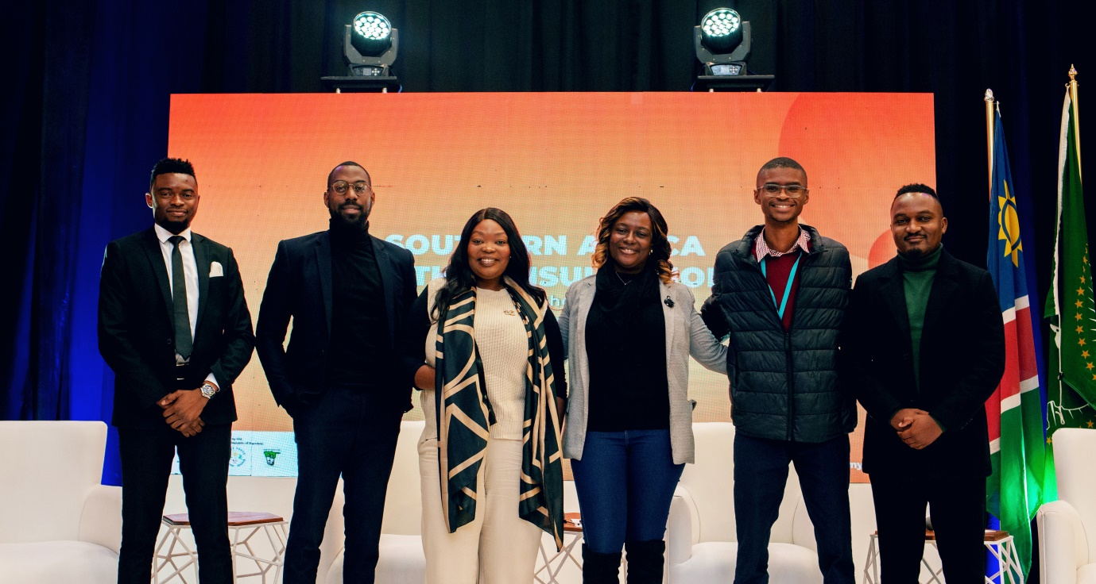*L-R: Reinhold Shiwagala; CJ Kumwe Dumeni; Stacey Susa-Pinto (Moderator); Claudia Boamah; Luimar Silva; Efraim Paulus***

The day’s focus was on the discussion on challenges and opportunities for women and youths in digital trade. It was acknowledged that in the AfCFTA protocol, there are already negotiations for the digitalization of trade; the commerce for electronic trading of goods and services. E-Commerce encompasses trading in both physical goods and services, which enables a wider scope of trade by widening access to an even larger market on the regional levels. There were also questions raised on cybercrimes, logistics, data protection and procedures around virtual trading to fully benefit from it.

Challenges around infrastructure, information access and the political environment especially for Namibia was expounded on, as areas that needed addressing before the women and youths can fully benefit from e-commerce.

**Moderator**: Ms. Stacey Susa-Pinto, CEO, Namibia Trade Forum

**Panelists:**

1. Ms. Claudia Boamah, Manager, MSME Ecosystem Optimization
2. Mr. Reinhold Shiwagala, CEO, Taxi Connect
3. Luimar Silva, Head of Sales, JABU
4. Efraim Paulus, National President, Junior Chamber International
5. Kumwe CJ Dumeni, CEO, Chommie Bites

The following were the discussion outcomes by each of the panelists;

**Ms. Claudia Boamah, Manager, MSME Ecosystem Optimization, Namibia Investment Promotion & Development Board**

She said that what really spurs the conversation on digital trade and commerce started with COVID 19 and the impact it had on physical access and functioning of the market spaces. That was the wakeup call to realizing that digital trade is a possibility and a necessity for Africans. She also stated that the physical market has rather tight competition around it, and a significant part of the solution to this is widening the access to markets beyond borders. She called for the integration of digital trade and the leveraging of the same for the purpose of export beyond the local markets available, business sustenance through digital modes.

We are at a stage where digital technology has become a catalyst for ensuring the implementation of polices and as such the youths and women and other stakeholders need to adapt and adopt the AfCFTA as a protocol that can uphold the law and ensure smooth virtual trading.

On key opportunities and the fast moving pace of technology, she said that there is need to figure out the best means of getting information and raising awareness for SMEs on opportunities in international, local, private and public entities. There is already an app for SMEs, the In4SME app where business owners can register and have access to such information from a scope as wide as possible. It also serves to increase access to information for all stakeholders involved in SMEs, including capacity building requirements that might be learned on a digital platform, necessary for these businesses.

**Mr. Luimar Silva, Head of Sales, JABU**

On one hand there are the manufacturers, and on the other hand there is the market space. Following the impact of COVID 19 and the restrictions on movements, there was a need to ensure access to these businesses, some basic needs, and that is the basis upon which JABU was initiated. Today, the initiative works with restaurants, shops and numerous wholesalers and retailers to smoothen the supply chain.

AfCFTA is part of the solution to the current challenges today, especially in enhancing access to markets for women and youths in trade.

**Mr. Efraim Paulus, National President, Junior Chamber International**

For us to be able to leverage the digitalization of trade, there is need to increase our digital literacy skills, as priority to allow the masses be able to use the available platforms. Digital skills are vital in ensuring the practicability of these ideas; we are then able to remove the fears of digital trading and transforming, and it will build trust in the traders from the consumers. NYC needs to start thinking of how we transact on a daily basis, especially introducing digital tools to the services youths access through NYC, to enable build the confidence of the people in digitalization. Digitalization ought to become part of our everyday life.

**Mr. Kumwe CJ Dumeni, CEO, Chommie Bites**

There is potential that lies in the leveraging of digitalization of trade for women and youths in Africa. There is also need for youths to create their solutions to the problems they are facing. Technology is able to create a platform in an income generating space; people are motivated by where the money is. Involving digitalization into such processes will then get a lot of people wanting to engage and be involved.

People have to be trained on how to use the digital platform to simplify the process, and this requires investment, but it will change the job creation and trade platforms and enhance engagements of the people.

**Mr. Reinhold Shiwagala, CEO, Taxi Connect**

Youth need to consider providing solutions for the challenges that they identify. Taxi connect was only formed after the co-founder faced challenges with the transport system. The conversation needs to start when one faces a challenge, which is an opportunity to provide or contribute to the solution.

## Audience Response

* Digital transforming is an opportunity that the youths ought to exploit. It is important to understand that IT and digital spaces can be quite intimidating at first.
* How does one narrow down their ideas from the numerous available one; focus on what one wants. An individual cannot solve all challenges. One has to consider other factors too.
* How does the AfCFTA enable young people to make money in the digital space?
* There are also platform ownership challenges and data ownership, and as such development in technology is not favorable for African youths. Does the protocol address that?
* Our economies to a large extent are dependent on extractive industries, mining, and as such there is need to convince the youths to consider other industries such as the creative and cultural economic industry. There is a growing awareness and recognition of these other sectors and their contribution to the national economy, and these policies need to focus on these other sectors as well.
* Some of the panelists spoke about identifying the problem and working on the solutions, and as such does the protocol address the creative industry space i.e. content creation and what not?
* There is a need for youths to be updated about the information that is available for their welfare.

## Call to Action

* Youths and women in trade need to learn the art of discipline especially when it comes to managing resources meant for innovations.
* Taking risks is important and staying on the process long enough to figure things out.
* Social capital and networking is of utmost importance. There is so much value in entrepreneurs collaborating with each other.
* Strengthen our startup culture, policy often times follows innovation, not the other way round, thus youths have to take initiative, think innovatively, and prepare each other as we await policies.

# SESSION 5

## Validation Exercise/ Recommendations to be included in the Protocols on Women and Youth in Trade and Digital Trade/Ecommerce.

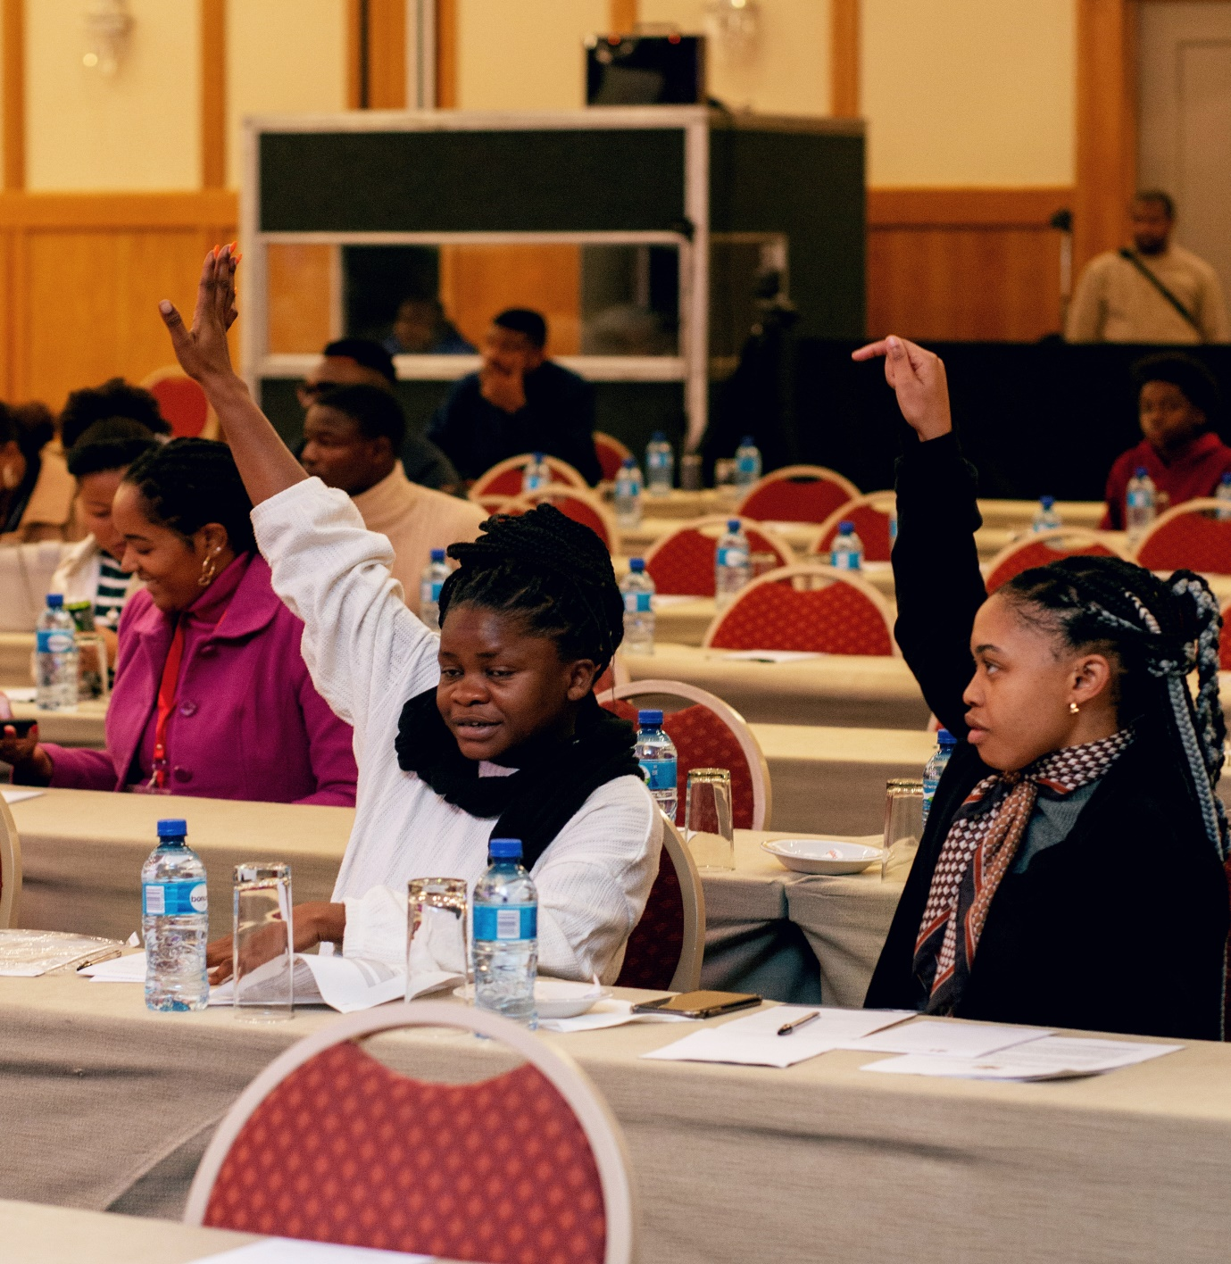*Participants second the recommendations from the meeting*

* Enhancing access to markets for women and youths especially when it comes to cross border trade.
* Simplification and translation of the Protocol to make it as palatable and easy as possible for understanding to the young people. Ethiopia has already commenced translating the protocol into Amharic and this is something other countries ought to take on.
* Youth are agents of change, and are tasked to carry forward the information they have got from the consultation, to the rest of the population.
* There is need to harmonize financial incentives given to Micro, Small and Medium Enterprises to ensure that countries are not competing in terms of attracting foreign direct investments. The draft protocol proposes giving financial incentives to youth and women led MSMEs, and as such harmonization of the financial incentives will be key in ensuring their regulation.
* Inclusion of people with disability in the Protocol as part and parcel of the development of all women and youths in trade.
* Dispute resolution needs to be realigned to specifically address the interests of women and youths in trade, rather than leaving it up to Partner States.
* Value addition especially in agriculture to ensure better realization of profits from the outputs.
* There is a need to leverage sports and its mainstreaming into the AfCFTA, as an opportunity for youth.
* Climate financing for trade and agriculture, for a sustainable future and to enhance the output from both agriculture and trade for women and youths.

# GENERAL CALL TO ACTION BY YOUTH DELEGATES

* Let us start providing and employing people in our areas. Young people should empower their own people and refrain from imported goods.
* On currency, there is a need for Africa to agree on the currency to be used while trading.
* Mainstreaming women and youths in trade and opportunities through the protocol.
* Youths should also take responsibility in finding solutions for themselves, and not leave everything for the States as stakeholders.
* There is need to tap into the agricultural sector for its numerous opportunities.
* Pan Africanism principles need to be adopted by youth to make the AfCFTA palatable and simplified for everyone
* Information asymmetry, to move the right information to the grassroots’ farmers and traders.

# CLOSING REMARKS

Ms. Ndiitah Nghipondokah-Robiati delivered a vote of thanks to the Ministers who attended the event, Hon. Lucia Ipumbu and Hon. Emma Kantema-Gaomas, youth Members of Parliament, the Presidential Advisor on Youth Affairs, Ms. Daisry Obal, Executive Chairperson of the National Youth Council, Ms. Sharonice Busch, United Nations Development Programme, AfCFTA Secretariat, Youth For Tax Justice Network, Panelists, Speakers, service providers, the media, exhibitors, participants and the technical team.

# GALLERY

